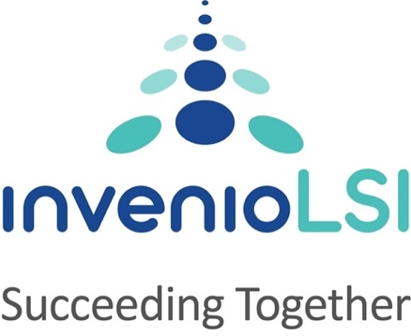
Invenio Business Solutions Limited
125 Wharfedale Road,
IQ Winnersh, Reading,
RG41 5RB
United Kingdom

Slavery and Human Trafficking Statement

- INTRODUCTION

INVENIO Business Solutions (Invenio) is required by the Modern Slavery Act 2015 to make an annual public statement of the steps it has taken to ensure that Modern Slavery is not taking place in any of its supply chains and in any part of its business. This statement includes information about its due diligence process in its business and supply chains. This statement pertains to the FY25 (April 2024- Mar 2025).

INVENIO is headquartered in Winnersh Triangle, Wokingham, UK with subsidiaries in USA, India, Mauritius, Fiji, Saudi Arabia, Bahrain, Qatar and UAE. Invenio is a Board of Directors governed organization led by an experienced professional CEO.

INVENIO is an SAP Gold Partner and its main service offerings are business consulting and technology services based on SAP solutions and digital enablement for its customers. The main delivery centers are based in India with smaller teams in other locations. Our consultants travel to customer locations in UK, Saudi Arabia, Qatar, Bahrain and Fiji.

INVENIO considers Modern Slavery as unethical and criminal, including all aspects of
Human Trafficking
Forced work through physical or mental threat
Servitude
Constrained or restricted freedom of movement for the workforce

INVENIO fully appreciates and abides by the UK Modem Slavery Act 2015 in letter and spirit. Invenio acknowledges its responsibilities in this relation and commits to complying with all the provisions of the Act. Invenio understands the requirement and its obligations to continuously monitor and review its internal practices in relation to its workforce and its supply chain for workforce.

INVENIO is opposed to modern slavery in all forms; human trafficking, slavery, servitude, forced labour, debt bondage, forced marriage, and child labour.

INVENIO ensures to review and hire employees after proper due diligence in all regions it operates in. The compensation paid and the employment terms in every region is compliant with the local labour laws like minimum wages, child labour, retiral benefits, vacation, time, equal opportunities, etc. Compensation of our employees is benchmarked with the industry best practices and trends in the region. Invenio also does due diligence of partners before entering into formal working relationship to ensure that the partner/ supply chain is clear about modern slavery and human trafficking and does not involve itself in any such aspects. Workforce is largely Full-time-employees with contract workforce comprising a meagre 4% of the overall size. Modern slavery is an absolutely non-negotiable aspect of Invenio’s working framework and workforce management.

- MODERN SLAVERY RISKS IN THE OPERATIONS AND SUPPLY CHAINS

During this Reporting Period, in assessing the risks of modern slavery for INVENIO, the following aspects:
- Supply Chain Risk - Supplier Industries INVENIO is aware of the potential risk of modern slavery in all countries and in all industries. As regards to our supply chain, INVENIO has not identified any areas of specific risk, and apply our engagement process and code equally across all its suppliers to minimize the risk of Modern Slavery in INVENIO’s supply chain.
- Supply Chain Risk Geographic Areas – INVENIO relies on international interconnected supply chains that are situated in countries generally recognized for their low susceptibility to incidences of modern slavery. By strategically establishing connections with suppliers in such countries, INVENIO aims to mitigate the risk of involvement in any form of modern slavery throughout its supply chains. This approach aligns with the company’s commitment to uphold ethical practices and promote human rights across its operations.

INVENIO considers its exposure to Slavery/ Human trafficking to be non-existent. It has not, to the best of its knowledge conducted any business with another organizations / partner which has been found to have involved itself with modern slavery, also it has a zero – tolerance approach to Modern Slavery. We are committed to acting ethically and with integrity in all our business dealings and ensure Modern Slavery is not taking place in our own business and supply chains.

INVENIO has a Slavery Compliance Officer (Katy Quilter, VP, Head of People Care and Services.) to whom all the concerns regarding modern slavery can be addressed, and who will then undertake relevant action in line with the organization’s obligations.

This statement is made4 in pursuance of section 54(1) of the Modern Slavery Act 2015 and will be reviewed each financial year.

